**Update the FILE NAME**

Rename this file to be **Design Project Form** with major and team number.

Examples: Design Project Form ME-12

Design Project Form BME-3

**____________________________________________________________________**

**PROJECT TITLE** *Building a filament extruder for optimized PET recylcing*

**____________________________________________________________________________**

**TEAM MEMBERS** *Blake Christiansen, ChemE*

*Samuel Leville, ChemE*

*Melanie Marszal, ChemE*

*Amy Pang, ChemE*

List team members in alphabetical order with majors after the name.

Use the following abbreviations in team listings: BME, EE, ME, ChemE, CompE, ES, CE.

EngM, EECE, EECS are NOT majors.

In cases of double or triple majors, the engineering major MUST BE listed first. For non-engineering majors, use the official VU course catalogue abbreviations. Examples: Chem, CSET, Econ, Math, PSci, Psy, Phys, etc. Correct: CS/Span and CE/Econ. Incorrect: Spanish/CS and CE/Economics.Majors: BME, CE, CS, ChemE, CompE, EE, ME (EngM, EECE, EECS are NOT majors)

Examples: Jacob Ayers, BME

Hannah Kang, BME

Dominique Szymkiewics, BME

Nora Ward, BME

Tommy Yates, BME/Econ

Eric Yeats, BME/Chem

**____________________________________________________________________________**

**ADVISER(S)** Professor Scott Guelcher, ChemE

Professor David Florian, ChemE

Skyler Hornback, ChemE

These individuals guided your project in an official capacity. Within the School of Engineering, use department abbreviations and do not distinguish rank. For those elsewhere at VU or VUMC, spell out department. Others, including those at other universities, use name and organization only, unless the person is a licensed Professional Engineer.

Examples: Professor Todd Giorgio, BME

Professor Florence Sanchez, CEE

Professor Steven Townsend, Department of Chemistry

Joseph Schlesinger, M.D., Department of Anesthesiology, VUMC

Ashley Majewski, Office of the Vice Chancellor Administration

Justin Corney, consultant

Kyle McLemore, P.E., AECOM

Jane Glaser, FedEx Express

**____________________________________________________________________________**

**SPONSOR** *Vanderbilt University School of Engineering  
 Vanderbilt University Office of Immersion Resources*

This is an entity,group, organization, or company, NOT a person.

Examples: Vanderbilt University School of Engineering

Vanderbilt University School of Medicine, Department of Radiation Oncology

Tesla

Institute for Space and Defense Electronics

DENSO

**____________________________________________________________________________**

**LOGO**



***Insert the logo for the entity above here***

This image identifies a group, organization, or company.

* Make sure the image is cleared by your advisers or sponsors.
* This image must be suitable for printing; not low resolution.

**____________________________________________________________________________**

**PROJECT ILLUSTRATION *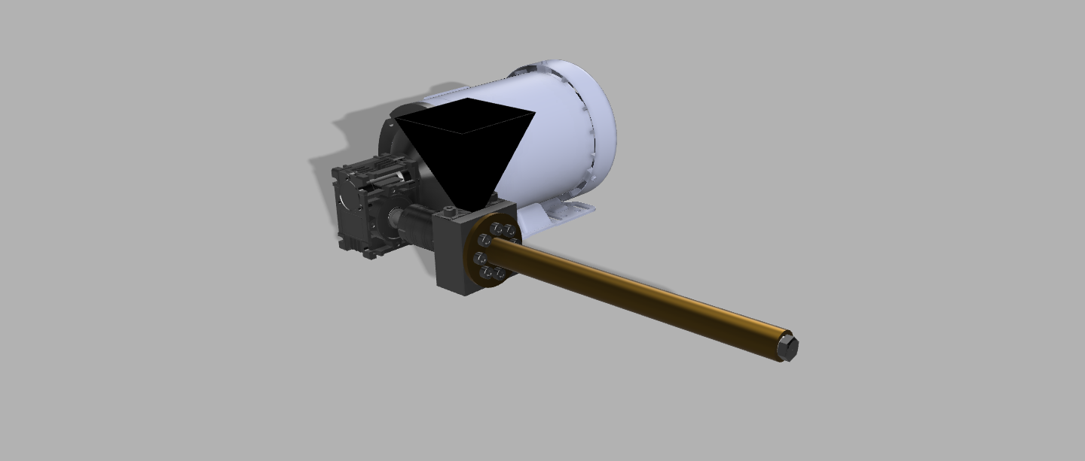***

* Original illustration (high-resolution photo, drawing, schematic, etc.; NO clipart).
* Make sure the image is cleared by your advisers or sponsors.
* No photo of your group unless shown working on the design project.
* Details and text labels easily read if printed at 8 cm by 4 cm.

**____________________________________________________________________________**

**PROJECT ILLUSTRATION CAPTION:** The assembly of key components of our PET extruder: motor, gearbox, coupler, flange, barrel, screw, die, and hopper.

A specific caption that stands alone and explains the illustration without relying on the text. Insert the caption here.

Example: The prosthesis hardware additions include a battery pack, microcontroller and electromyography muscle sensors.

**____________________________________________________________________________**

**PROJECT NARRATIVE *Insert the copy here***

Plastic bottles are one of the highest contributors to waste in the United States. Luckily, they can be recycled for a variety of purposes. Our team partnered with Vanderbilt recycling to utilize plastic bottle waste from students to supply 3D printing labs across campus with recycled PET filament. Many extruders exist to take pellets of certain types of plastics and produce strands of filament that can be fed into 3D printers. However, what this group aims to do is design an extruder that is optimized to take ground up plastic bottles and turn them directly into filament. The team is using machinery in the Digital Fabrication Lab to grind up bottles from Vanderbilt recycling, using simulation software to determine optimal extruder parameters for their regrind, using CAD to design their extruder, and building the extruder from scratch. They hope to use their finished extruder to create a circular plastics economy at Vanderbilt, where students in years to come can continue to use bottles from Vanderbilt recycling to create filament with satisfactory material properties and supply this filament to various 3D printing labs and makerspaces on campus.

This section is your 125-200 word description of your project.

* The need/requirement or problem being addressed
* The overall goal – what the project is to accomplish
* The main elements of the project design or solution
* The advantages over previous or existing solutions
* The results intended or anticipated – You won’t have completed your project so you cannot report on the actual results

**PLEASE CAREFULLY READ THE MORE DETAILED INSTRUCTIONS BELOW.**

**____________________________________________________________________________**

**CONTACT INFORMATION *Blake Christiansen,*** [***blake.a.christiansen@vanderbilt.edu***](mailto:blake.a.christiansen@vanderbilt.edu)***, 256-924-4803***

Name, email address and cell number of a responsible contact for your group. This is the person catalog editors will call if they have questions about the narrative, illustration, etc.

Example: Jane Smith, [jane.smith@vanderbilt.edu](mailto:jane.smith@vanderbilt.edu), 615-555-6155

**THE INSTRUCTIONS Above (in light blue) AND ALL MATERIAL BELOW SHOULD BE OMITTED FROM YOUR FINAL SUBMISSION**

**~~~~~~~~~~~~~~~~~~~~~~~~~~~~~~~~~~~~~~~~~~~~~~~~~~~~~~~~~~~~~~~~~~~~~~~~**

**Further instructions on Narrative Content**

The description must make sense standing by itself. In no more than 200 words and no less than 125 words, state clearly:

For more information about the Design Day book, here are previous years to view:

# vu.edu/design-day

<https://engineering.vanderbilt.edu/design-day/projects/index.php> (This has the last 10 years of Design Day books)

# Tutorial video

Review instructions for this assignment by viewing the tutorial video at: <http://engineering.vanderbilt.edu/design-day/instructions.php>

(Submission will vary by department)

**Specific abbreviations to be used at all times**

Use **IoT** for Internet of Things.

Use **3D** printing, not 3-D printing. However, 3D-printed as a compound adjective has a hyphen.

Use **VUMC;** do not spell out Vanderbilt University Medical Center.

**Person**

Use mostly third person but if necessary, you may occasionally use first person. Third person means that you mostly avoid personal pronouns and use pronouns such as “they” and “he, she, or it.” First person means using words like “we” or “our.” It is acceptable to refer sometimes to your team as “we” or “our team.”

These are third person examples:

The team designed and tested a hybrid printer.

The goal was to increase efficiency.

First person examples:

We measured the forces using force sensing resistors.

Our team optimized traffic flow at the intersection.

Our major concern was to avoid lost or corrupted data.

**Voice**

Prefer the active voice whenever possible. It will enliven or activate your writing.

Avoid unnecessary passive voice. Passive voice dilutes the action by weakening the verb, increasing wordiness, and delaying the meaning.

Examples:  
Passive: Completion of a reliable rocket system was accomplished by the aerospace team.

Active:The aerospace team completed a reliable rocket system.

**Tense**

Use past and present tense appropriately. Use past tense verbs for your completed work. Use present tense verbs for current work. There is usually no need for future tense.

Examples of past tense:

1. Our team **designed** a novel cryogenic injection system.

2. The model **showed** that the extraction rate **increased** when the temperature **increased** by 5 degrees C.

Example of present tense:

Work **continues** on the canoe project.

Example of present progressive tense:

1. We **are testing** two different memory devices to determine which is more resistant to radiation.

2. The next step **is optimizing** the gear ratio to improve widget efficiency

One problem to watch for is shifting verb tense unnecessarily. Use past tense to describe action that is already completed, that is, to describe what you have done thus far.

**4 C’s**

Make your description readable. Remember the four C’s:

**Complete**: Cover all major parts of the project

**Concise**: Be brief. Avoid wordiness or unnecessary  
 information

**Clear**: Write for the reader, not yourself

**Cohesive**: Create text to flow easily from one idea to   
another

**Submission requirements**

Submit this file by the deadline announced by your instructor.

